Midwives in Hard-To-Reach Areas: A Vital Resource for Climate Change Advocacy.

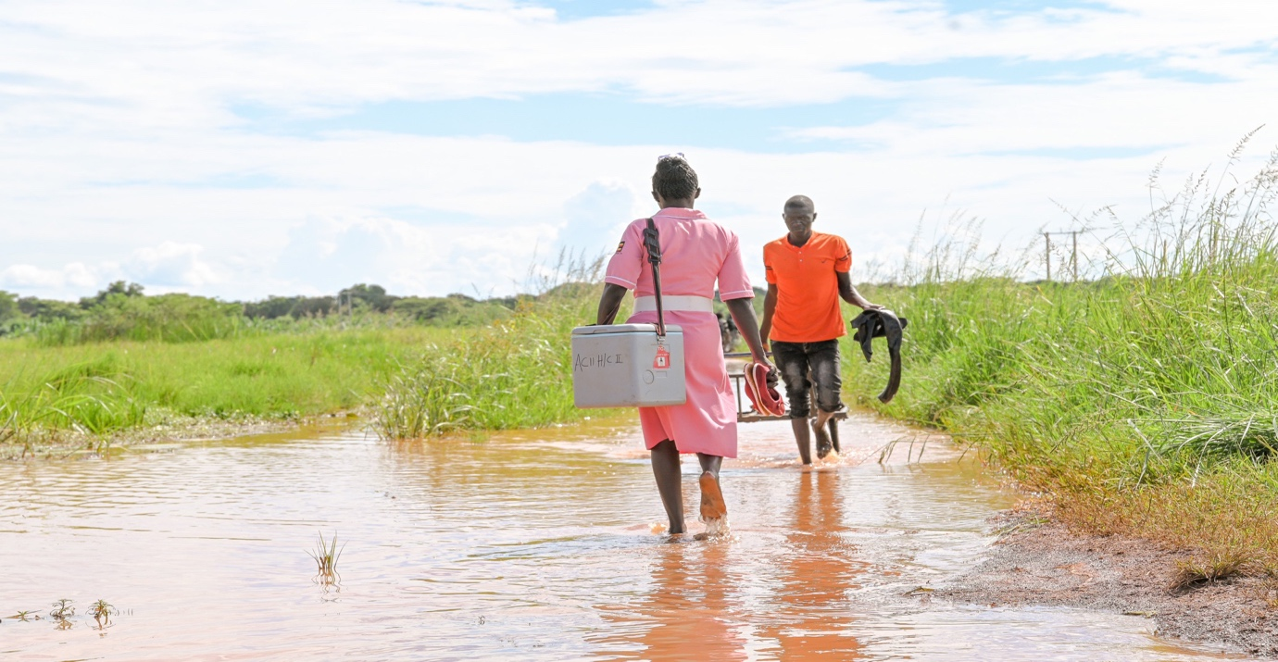 | Midwives have continued to play a critical role in ensuring the well-being of mothers and children in Uganda, particularly in hard-to-reach areas. Despite the numerous climate change challenges, these dedicated professionals tirelessly work to improve maternal and child health outcomes.  Amidst challenges like shortage of skilled professionals, poor roads, poor working conditions, long working hours, limited resources and inadequate infrastructure. These dedicated professionals have continuously provided skilled care during child birth saving lives of many mothers and their babies.

Midwives in hard-to-reach areas are often on the front lines of climate change activism due to the close connection that exists between environmental factors and maternal and infant health. These midwives witness the first-hand impact of climate change on their communities, including extreme weather events, food insecurity, and the spread of infectious diseases.  As advocates for maternal and infant health, midwives in hard-to-reach areas are uniquely positioned to raise awareness about the importance of addressing climate change to protect the health and well-being of mothers and babies. Midwives often times engage in activities such as educating their communities about the links between climate change and health, promoting sustainable practices in their own work, and advocating for policies that support climate action. | 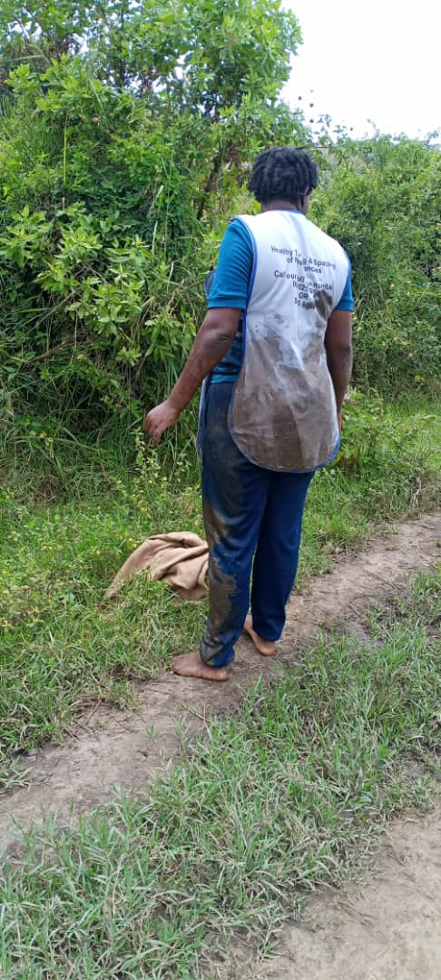
Additionally, midwives are often trusted members of their communities and can use their influence to mobilize others to take action on climate change. Midwives should be supported to continuously integrate climate change advocacy into their work in order to obtain a significant impact in building more resilient and sustainable communities for future generations.

By Niwamanya Ritah

